**Creating Parameters in QuickSight**

1. **Open Your Analysis:**
   * Go to QuickSight and open the analysis where you want to add the parameter.
2. **Add a Parameter:**

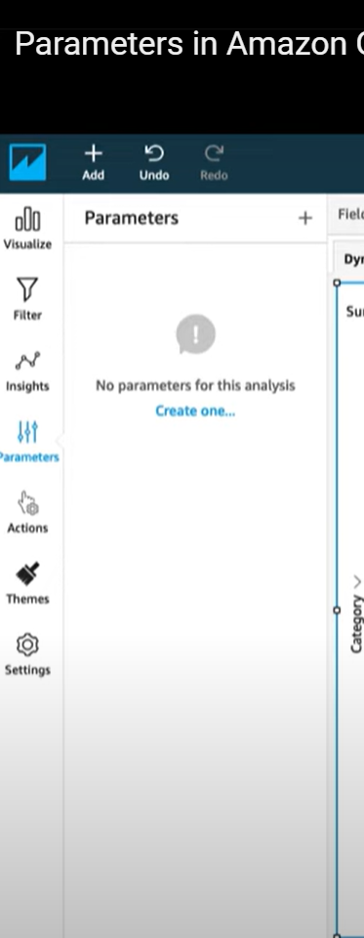

* + Click on the **“Parameters”** pane on the left sidebar.
  + Click **“+ Add”** to create a new parameter.

1. **Configure the Parameter:**
2. 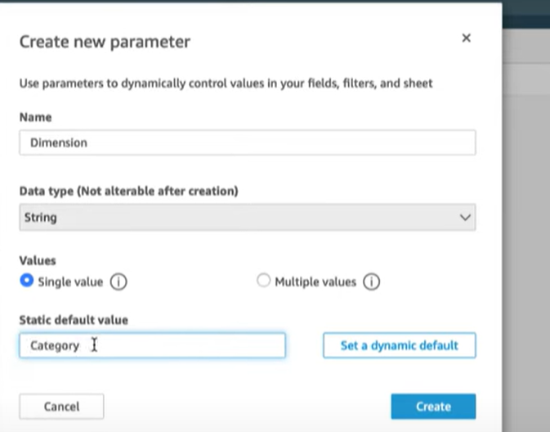
   * **Name:** Give your parameter a meaningful name.
   * **Data Type:** Choose the data type (e.g., String, Number, Date).
   * **Value Options:**
     + **Static Values:** Define a list of static values that the parameter can take.
     + **Dynamic Values:** Optionally, use a dataset to provide dynamic values.
   * **Default Value:** Set a default value for the parameter.
3. **Use the Parameter in Calculated Fields or Filters:**

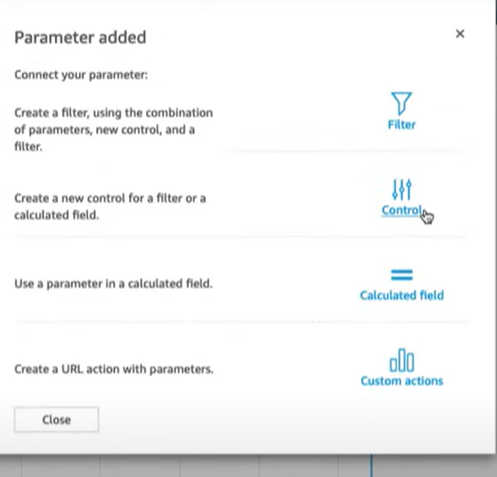

* + After creating the parameter, you can use it in calculated fields or filters.
  + For example, to filter data based on the parameter, go to the **“Filters”** pane, add a filter, and choose the parameter as the filter condition.

1. **Add a Control for the Parameter (Optional):**

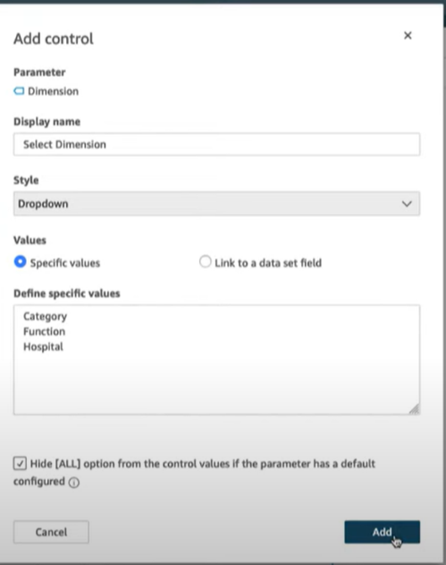

* + To make the parameter adjustable by users, add a control to your dashboard.
  + Click on **“Add control”** in the dashboard, select the parameter, and choose the control type (e.g., dropdown, slider).

1. **Apply and Save:**
   * After setting up the parameter and controls, apply them to your visuals and save your changes.